**Abdullahi Mohamed - M00810926**

**Middlesex University, London**

**Title: "Critical Analysis of Healthcare Information System Failures: Identifying Key Factors and Implementing Solutions"**

### **Introduction**

Information systems are essential to healthcare organizations because they enhance patients' care and operations. This includes managing data, scheduling appointments, documenting patient records, and exchanging information across healthcare branches. These systems are important to help deliver a quality service to users. However, healthcare information systems deal with obstacles that can hinder their success. Lack of success within systems can lead to harsh results, delayed treatments or patients can be harmed. For example, poor user experience design and insufficient training of employees are common factors that contribute to failures. The essay investigates the key elements that result in unfulfilling information systems within healthcare, understanding their impact on healthcare results and then proposes solutions to address issues. Another factor are technical issues, project management issues, human factors, misuse of goals, proposing quality management methods, project management frameworks, change management strategies and risk management tools as a prevention of failure.

### **Discussion of Failure Factors**

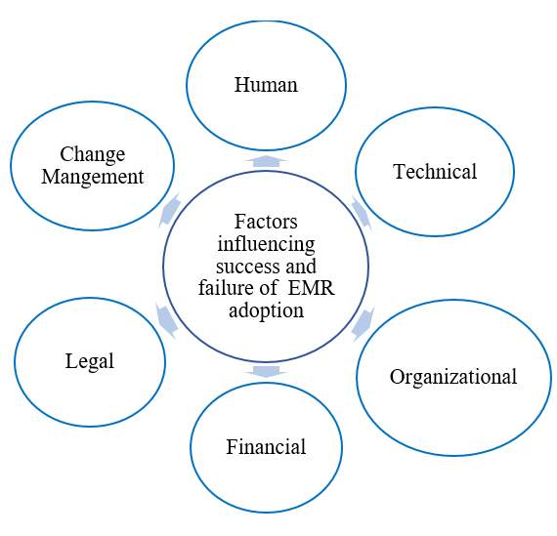

Figure 1- From ResearchGate (2020): "The six key categories of factors influencing success and failure of adoption of EMR"

#### **Technical Issues**

Common elements resulting in failure of healthcare information systems are technical issues, these include system crashes and errors with data. Unpredicted delays can make patient information inaccessible, leading to slower treatment and affecting quality care of patients. System crashes for instance can lead to unexpected downtime, making critical patient information inaccessible to healthcare professionals. Such disruptions can delay treatment, resulting in compromised patient care. (Zhou et al., 2019) stated technology must be used correctly by healthcare providers for the sake of their patients. Data entry errors can stem from unsuccessful designed user interfaces or lack of interaction between staff. Flawed data inserted can lead to mistakes within diagnosing a patient, possibly inaccurate treatment and further health issues may arise. As stated by (Zhang, 2008) data entry errors are misinterpretation of documents. Inaccurate data can lead to wrong diagnoses, inappropriate treatments, or endanger patients. Healthcare systems deal with large sums of data, a failure to ensure data accuracy can lead to fatal consequences.

**Project Management Issues**

Below par management is common in healthcare information systems because IT projects within healthcare are complex, including multiple stakeholders, such as healthcare providers, IT professionals and regulations from government. When projects are not executed or planned accordingly, the results often are inadequate and lackluster. Usual issues in managing projects are poor planning, insufficient budgeting, unrealistic timeline and lack of stakeholder involvement. Deploying systems without regular testing can result in functionality problems and long-term issues highlighting the system is not ready. Lack of interactions between team members and stakeholders can result in a misunderstanding of the needs of healthcare providers. (Cristina et al., 2024) believes that projects should be produced to enhance care of patients and ensure regulation requirements are met.

#### **Human Factors**

Human factors are common within failure of healthcare information systems, this can include lack of user training, dull system design that contribute to a low-quality system. Healthcare staff are used to paper systems, introducing new digital systems can lead to disagreements between employees and are reluctant to change. This can lead to endangerment of patients, frustrations of wrong procedures and poor performances. (Charles et al, 2022), states embracing the future of healthcare should be advocated to patients.

#### **Business Objectives**

Not addressing stakeholders’ needs can result in important areas of concern not being implemented, which could lead to failure within the business. Information systems within healthcare should be utilized to support strategic objectives. This can include improving operational efficiencies, reducing costs and patient experience, for example if healthcare businesses can invest in advanced information systems without acknowledging stakeholders’ needs, without initiation from all groups, the system is unlikely to achieve long-term success. (Bush et al., 2009) journal highlights the severity of information systems positioning with organization objectives and challenges faced within the industry.

**Financial Impact**

According to (Van Den Bos et al., 2015) states system failures cost healthcare systems $17.1 billion annually, with $3.7 billion being serious patient safety incidents meaning it shouldn't have happened if providers follow safety procedures. These errors lead to patients staying longer at the hospital and overwhelming staff, increasing stress and lessening productivity. These financial constraints highlight the need for an effective system and implementation of management tools to minimize errors.

**Inefficiencies Impact**

(Cylus et. al, 2017) highlights inefficiencies in health system can often stem from misusing resources, poor coordination and interrupted care, these all negatively impact delivery care. Inadequate integration between healthcare providers can lead to delays, poor patient outcomes and meaning the need for improving efficiency is important. Health systems face issues with poorly run management or outdated infrastructure; to address these problems, they need to improve patient management, a collaborative approach to care delivery.

### **Proposed Solutions**

#### **Quality Management Methods**

Total Quality Management focuses on customer satisfaction, stakeholder involvement, and continuous improvement to address issues within healthcare information systems. TQM can be applied to developing and maintaining a system, meeting demands of healthcare providers. TQM can recognize and address issues instantly in the development process, preventing further problems (Alzoubi et al., 2019).

Another framework is Six Sigma, this methodology helps reduce flaws and variation within the process. For healthcare, information systems can be used to reduce errors in entering data, increase overall operational efficiency and an improved system. The approach of Six Sigma can help healthcare organizations to find root causes of errors, enabling them to implement correct solutions and reduce the likelihood of system failure (Antony et al., 2018).

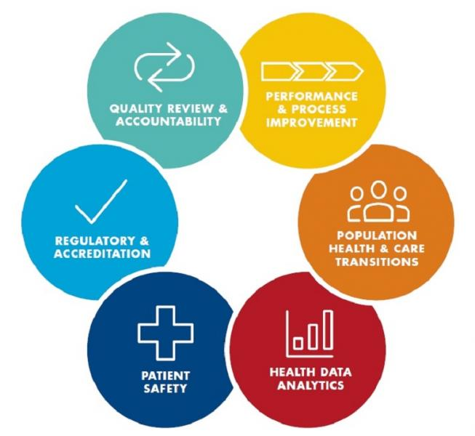

Figure 2- From ProcessExam (2025): A Six Sigma in healthcare diagram

**Project Management Frameworks**

Project management is vital to the success of healthcare information systems, a common framework is PRINCE2. It stands for projects in controlled environments, a structured methodology that specifically has clear roles, responsibilities, and objectives. This aligns with healthcare organizations, where many individuals involved in the project are synchronized to work effectively and understand their roles. By using PRINCE2, healthcare projects can be planned responsibly, risks are managed, and resources are assigned carefully (Rahman and Ahmed, 2024). Differently, Agile is another framework but focuses on flexibility, team collaboration and repetitive development. Agile is suitable to improve healthcare information systems, as it refines systems in response to feedback from users, making sure the final system has met the expectations of business (Desai et al., 2024).

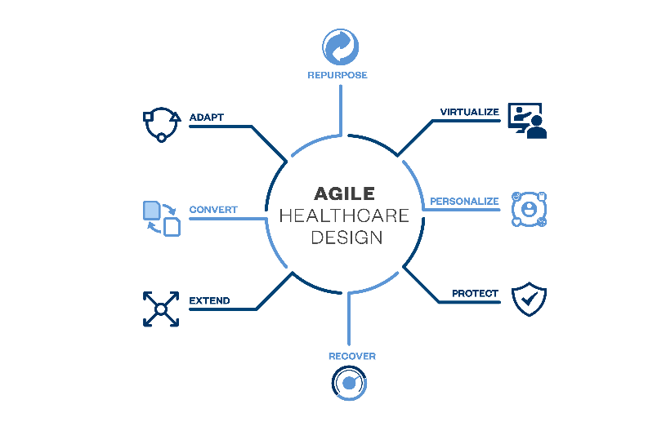

Figure 3 - From EwingCole (2025): Agile healthcare design diagram

#### **Change Management Strategies**

Healthcare information systems always need to adjust, the reasoning being is to prevent failures and maximize success. Changing strategies can help employees adapt to a new system that they are not familiar with, providing essential training and addressing queries. (Ravi et al., 2022) highlights Kotter’s 8-Step Change Model as a framework that provides structure, and the aim is to effectively implement changes by developing a clear vision. By letting users be aware from the start and addressing their issues, this can help healthcare information systems to reduce stagnation, likelier to adapting a successful system. (Barrow et al 2022) believes the 3-step process of Lewin helps with adjustment, it includes the needs for change, starting a process of change and establishment of a new status. This correlates with healthcare because change is inevitable within the business and ensuring effective change will benefit the business.

#### **Risk Management Tools**

SWOT Analysis analyzes internal and external factors that can affect a system, healthcare organizations can make informed decisions to implement strategies to deal with issues. (Yermukhanova, L. et al, 2022) stated SWOT analysis is a necessary element within healthcare information systems, highlighting the strategic gain in implementing it correctly.

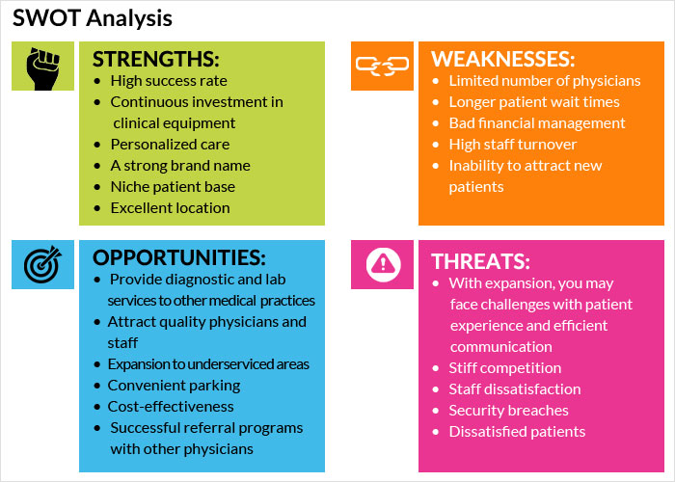

Figure 4- From Practice Builders (2023): The SWOT analysis diagram

**Conclusion**

To conclude, the failure of the information system within healthcare is caused by various factors, poor management of project, technical faults and misunderstandings business goals. These failures lead to further issues including delay in treatment and endangering patient life. Nevertheless, by implementing quality management tools such as TQM and Six Sigma, project management frameworks such as PRINCE2 and Agile, changing management strategies and utilizing risk management tools like SWOT analysis, can help healthcare organizations to reduce the likelihood of system failure. This paper addresses the failing factor, financial impact of inefficient system. By evaluating and refining information systems, healthcare can meet the needs of patients, providers and stakeholders.

**References**

Antony, J., Palsuk, P., Gupta, S., Mishra, D. and Barach, P. (2018) 'Six Sigma in healthcare: a systematic review of the literature', *International Journal of Quality & Reliability Management*, 35(5), pp. 1075–1092. Available at: <https://www.emerald.com/insight/content/doi/10.1108/ijqrm-02-2017-0027/full/html> (Accessed: 8 February 2025).

Alzoubi, M.M., Hayati, K.S., Rosliza, A.M., Ahmad, A.A. and Al-Hamdan, Z.M. (2019) 'Total quality management in the health-care context: integrating the literature and directing future research', *Risk Management and Healthcare Policy*, 12, pp. 167–177. Available at: <https://pmc.ncbi.nlm.nih.gov/articles/PMC6765328/> (Accessed: 8 February 2025).

Barrow, J.M. and Annamaraju, P. (2022). *Change Management in Health Care*. StatPearls [online]. Available at: <https://www.ncbi.nlm.nih.gov/books/NBK459380/>. Accessed 12 February 2025.

Butcher, C.J.T. & Hussain, W., 2022. Digital healthcare: the future. *Future Healthcare Journal*, 9(2), pp.113-117. [Digital healthcare: the future - PMC](https://pmc.ncbi.nlm.nih.gov/articles/PMC9345235/) [Accessed 6 February 2025].

Bush, M., Lederer, A. L., Li, X., Palmisano, J., & Rao, S. (2009). The impact of customer relationship management capabilities on firm performance. *Journal of Strategic Information Systems*, 18(3), 122-133. Available at: <https://www.sciencedirect.com/science/article/abs/pii/S1386505609000215>. Accessed February 8, 2025.

Cristina, M. (2024). Project management in healthcare: An examination of organizational competence. *Heliyon*, 10(15), e35419. Available at: <https://doi.org/10.1016/j.heliyon.2024.e35419> [Accessed 5 February 2025].

Desai, M., Tardif-Douglin, M., Miller, I., Blitzer, S., Gardner, D.L., Thompson, T., Edmondson, L., and Levine, D.M. (2024) 'Implementation of Agile in healthcare: methodology for a multisite home hospital accelerator', *BMJ Open Quality*, 13(2), e002764. Available at: <https://pmc.ncbi.nlm.nih.gov/articles/PMC11131107/> (Accessed: 8 February 2025).

Rahman, M.S. and Ahmed, E. (2024) 'Integrating PRINCE2 and Agile Methodologies in Software Development: Unveiling Opportunities and Addressing Challenges', *IEEE*. Available at: <https://ieeexplore.ieee.org/abstract/document/10823492> (Accessed: 8 February 2025).

Ravi, S., Patel, S.R., Laurence, S.K., Sebok-Syer, S.S., & Gharahbaghian**, L.** (2022). Kotter’s 8 stages of change: Implementation of clinical screening protocols for assessing patients for COVID-19 – a review of an academic medical centre’s preparedness. *BMJ Leader*. Available at: <https://bmjleader.bmj.com/content/leader/early/2022/04/20/leader-2020-000379.full.pdf> [Accessed 11 Feb. 2025].

Yermukhanova, L., Buribayeva, Z., Abdikadirova, I., Tursynbekova, A., & Kurganbekova, M. (2022). SWOT Analysis and Expert Assessment of the Effectiveness of the Introduction of Healthcare Information Systems in Polyclinics in Aktobe, Kazakhstan. *Journal of Preventive Medicine and Public Health*, 55(6), 539-548. <https://doi.org/10.3961/jpmph.22.360>. [Accessed February 12, 2025]

Zhou, Q., Wei, D., Li, L., 2019. Categorized according to the stage, mechanisms, and strategies of neurodegenerative diseases. *PMC*. Available at: <https://pmc.ncbi.nlm.nih.gov/articles/PMC7510167/> [Accessed 5 February 2025].

Zhang, J., 2008. Analysis of data errors in clinical research databases. *ResearchGate*. Available at: <https://www.researchgate.net/publication/23463400_Analysis_of_Data_Errors_in_Clinical_Research_Databases> [Accessed 5 February 2025].

Van Den Bos, J., Rustagi, K., & Gray, T. (2015). A $17.1 billion problem: The annual cost of measurable medical errors. *PSNet*, February 3. Retrieved from <https://psnet.ahrq.gov/issue/171-billion-problem-annual-cost-measurable-medical-errors> [Accessed 15 February 2025]

Cylus, Jonathan, Papanicolas, Irene, & Smith, Peter C. (2017). Identifying the causes of inefficiencies in health systems. *Eurohealth: Quarterly of the European Observatory on Health Systems and Policies*, 23(2), 3-7. Available at: [LSE Research Online](https://eprints.lse.ac.uk/83004/). [Accessed on: February 15, 2025]

Processexam. (2025). *Six Sigma in the Health Care Industry*. Processexam. Available at: <https://www.processexam.com/six-sigma-health-care-industry> [Accessed 15 February 2025].

Practice Builders. (2023). *SWOT: A self-exam to identify primary areas of focus*. Practice Builders. Available at: <https://www.practicebuilders.com/blog/swot-a-self-exam-to-identify-primary-areas-of-focus/> [Accessed 15 February 2025]

ResearchGate. (2020). *The six key categories of factors influencing success and failure of adoption of EMR*. Available at: <https://www.researchgate.net/figure/The-six-key-categories-of-factors-influencing-success-and-failure-of-adoption-of-EMR_fig2_346644260> [Accessed 16 February 2025].

EwingCole. (2025). *Agile healthcare design: Improving readiness and resiliency*. Available at: <https://www.ewingcole.com/agile-healthcare-design-improving-readiness-and-resiliency-2/> [Accessed 17 February 2025]